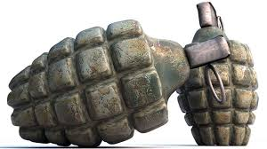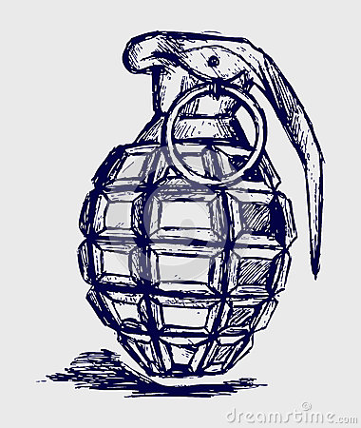

Start of the First Grenade
The first grenades were made in 1914 often hand-made, consisting of old cans filled with nails and bits of metal and packed with gunpowder. They often proved as dangerous to their makers as to their intended targets, due to the risk of premature explosion. Mills bomb, was one of the war's most effective infantry weapons. It was first issued to troops in the spring of 1915. After pulling the safety pin, the thrower had about five seconds before the grenade exploded. Generally lethal within a ten metre radius, the explosion sent pieces of metal up to a range of 200 meters.

Were the grenades successful during WW1? Yes, it was very successful during WWI because it was effective to killing soldiers in the trenches. The grenade was successful since WWI & continues to use in modern day. The greatest grenade battle was in 26 & 27 July 1916.

Which countries used the grenades?
Great Britain, Germany, Russia, United States, used hand grenade as a weapons during WW1

Illustration behind the picture:

The illustration that we made is A grenade is essentially a small bomb, but works like a simple firecracker. A firecracker is made up of a paper body filled with gun powder containing a small fuse. When the fuse is lit, it burns down to the powder and causes the gun powder to explode. A grenade works exactly the same way, except that a mechanical device instead of a match lights the grenade's fuse which has polymers that can be used for the fragmentation grenade causing strength and processing A variety of metals and shapes are used for the fragments and the casing. The molding method can also be varied.

